Secondary wastewater treatment
Biological treatment

Organic substance :
Organic substance is unstable substance, composed of the following elements:
C O H N P S
C: Carbon
O: Oxygen
H: Hydrogen
N: Nitrogen
P: Phosphorous
S: Sulphar

Types of organic substance :
1- Biodegradable organic substance ( 95 - 96 % of total organic substance).
It is the organic substance which can be decomposed by the microorganisms, such as hydrocarbons, proteins, ..ext.
2- Refectory (4 - 5 % of total organic substance)
It is the organic substance which can't be decomposed by the microorganisms, such as cellulose, pesticides, ..ext.

Stabilization process :
it’s the process in which unstable organic matter is changed to stable matter using microorganism such as bacteria.

Microorganisms
C O H N P S CO2
Organic H2O
(unstable Compounds) SO4
PO4
NO3
Inorganic matter
(stable products)

Many microorganisms

Biological process :
It’s a process involving microorganism to transform organic substance from a complex unstable state to a simple state matter, this process is characterized by a realize of energy which used by bacteria for movement and reproduction.
Secondary treatment are sometimes called oxidation units since their main function is to oxidize organic matter to stable matter through the activity of aerobic bacteria living in these units.

Bacteria:
Bacteria is a single microscopic cell.
80% water
90% organic

20% solids
10% inorganic
pH = 4 – 9.5
Temperature -2 – 65 ◦C.

Types of bacteria with respect to temperature:
1- Cryplophilic bacteria: -2 – 30 ◦C
2- Mesophilic bacteria : 30 – 45 ◦C
3- Thermophilic bacteria: 45 – 65 ◦C

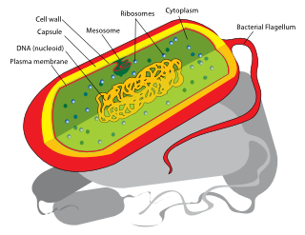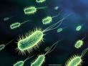

A schematic diagram of bacteria
A microscopic photo of bacteria

Parameters affecting biological process :
1) Temperature: the rate of reaction increases as temperature increase.
2) Presence of oxygen
Aerobic reaction > Anoxic > Anaerobic reaction
3) Composition and concentration of organic matter.
4) Concentration of microorganisms.
5) PH value (4 - 9.5)
6) Humidity: the rate of reaction decreases as the water content decreases.
7) toxic matter.
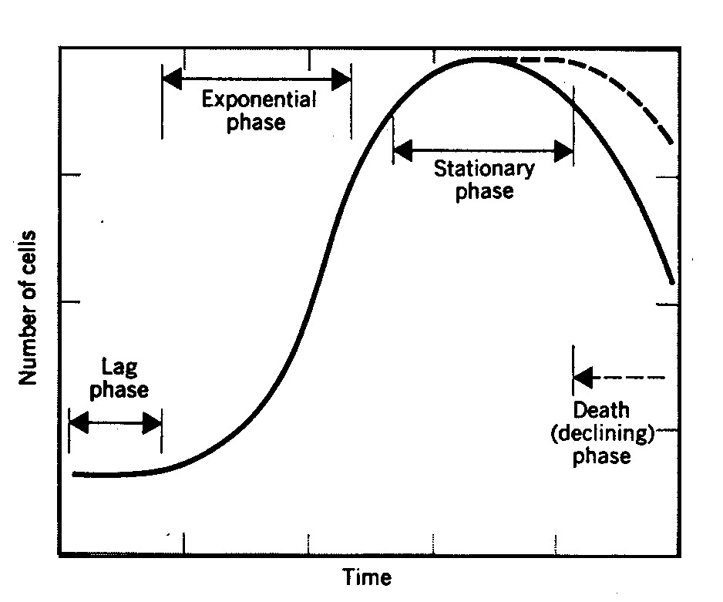
Growth characteristic curve of bacteria

The reaction between the bacteria and the organic matter occurs
1- On inert media and it called attached growth reactor such as trickling filter.
2- In suspension and it called suspended growth reactor such as activated sludge process.

The objectives of biological treatment:
The removal of 1- dissolved organic matter.
2- colloidal solids.

Two units process:

Biological

Reactor
Final
Settling
Tank
Stable matter
Stable matter

+ new bacterial
cells
Dissolved organic

Colloidal solids
Sludge

